Lockdown and emergency measures in Europe – current state of play (Update 24/11/20)
Notes:
- In general, distances of 1.5 metres must be kept as part of physical distance measures. This document only specifies where there are different national requirements.
- Figures for infection rates over the past 14 days in EU Member States were gathered on 24 November 2020.
- Nightlife establishments are as a general rule closed across Europe.
Austria  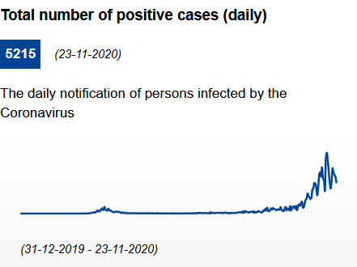 | Infection rate (cumulated past 14 days): 1057 cases per 100.000 inhabitants.  General information: From 17.11.2020 to (at least) 06.12.2020, Austria faces tougher anti-coronavirus restrictions. A mask must be worn in all indoor public areas. In all public places (indoors and outdoors), people who do not live in the same household must keep a distance of at least one meter from each other. All events are cancelled (with some exceptions such as demonstrations and professional sports). People are asked to keep their social contacts to an absolute minimum. Other than people in the same household, contact is restricted to partners, relatives, and caregivers. Funerals are permitted with a maximum number of 50 persons. People are asked to stay at home as much as possible. You may leave your home only for essential reasons, such as professional purposes, medical assistance or supervision. All shops that sell non-essential items are closed. Supermarkets, tobacco shops, banks, post offices, kiosks, and bicycle shops are allowed to remain open between 06.00 and 19.00. Fuel stations and pharmacies can stay open longer. A contact tracing tool Stopp Corona App is available.  Hotels: Hotels will only be allowed to host business clients. A 1.5-metre distance must be kept between those who do not live in the same household. Hotels participating in the government’s test programme have the "Sichere Gastfreundschaft" (safe hospitality) seal. Participating establishments commit to various criteria, with an emphasis on regular COVID-19 tests for staff. All Austrian accommodation providers and restaurants can have their staff tested in line with the government’s "Sichere Gastfreundschaft" initiative.  Bars and restaurants: Restaurants, bars and cafés are only allowed to provide take away orders (between 6.00 and 19.00) or home delivery (24 hrs).
Azerbaijan  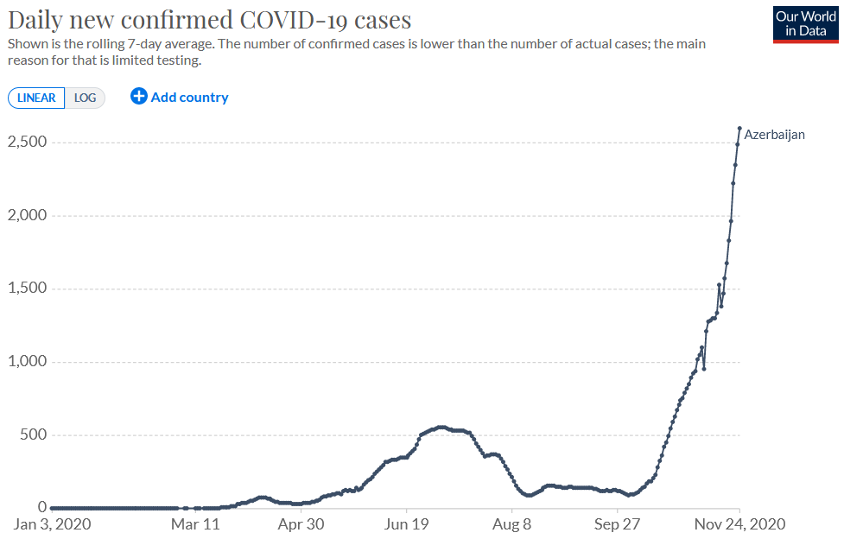 | General information: COVID-19 lockdown restrictions extended until 2 November. A military curfew is still in effect from 9:00 pm to 6:00 am (21:00 to 06:00) every day in Baku, Ganja, Sumgayit, Yevlakh, Mingachevir, Naftalan, Absheron, Jabrayil, Fuzuli, Agjabadi, Beylagan, Agdam, Barda, Tartar, Goranboy, Goygol, Dashkasan, Gadabay, Tovuz, Shamkir, Gazakh and Agstafa districts.  Azerbaijan authorities announced on Friday, November 20, that existing restrictions introduced due to COVID-19 have been extended until December 28. The government stated that all restaurants, cafes, and shops selling non-essential items will close over weekends. Shops selling food and pharmacies will remain open.
Belgium 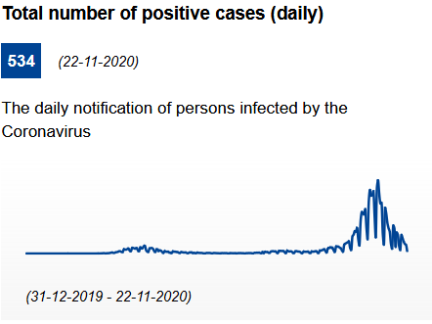 | Infection rate (cumulated past 14 days): 500 cases per 100.000 inhabitants.  General information: Country under lockdown until 13.12.2020. There is a curfew from midnight to 05.00. In Brussels and Wallonia there is a curfew from 22.00 to 06.00.Working from home is compulsory where possible. From the age of 12, wearing a face mask of any fabric to cover mouth and nose is mandatory in all closed spaces open to the public. Until 13.12.2020, gatherings in public spaces are limited to four people. At home, people can receive maximum one visitor from outside the household. Non-essential shops are closed, but it is possible to order online and to pick up purchases ("click & collect" and online shopping remain possible). Supermarkets may only sell essential goods. t is prohibited to sell alcoholic beverages after 20.00. Nightshops must close at 22.00, and they will also have to stop selling alcoholic beverages after 20.00.  In Brussels, a safety label has been developed to reassure visitors that the site, venue or establishment in question is safe. The criteria for receiving such a label are based on checklists drawn up on the basis of specific protocols, developed in close cooperation with sectoral entities and representatives.  Hotels: Accommodations (hotels, B&B's etc.) may be opened, with the exception of their restaurants, bars and communal facilities (pool, fitness). Guests are only allowed to have meals in their room. Holiday parks (campsites, bungalow parks) are closed, with the exception of holiday residencies, bungalows, chalets, and camping equipment intended for use by the owner, or a household that has habitual residency there.  Bars and restaurants: Restaurants, bars and cafés are closed. Take away meals are permitted until 22.00. It is forbidden to sell alcoholic beverages after 20.00.
Bulgaria  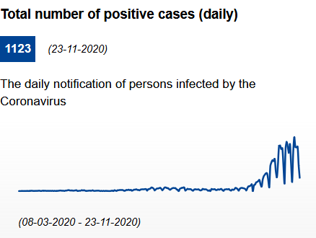 | Infection rate (cumulated past 14 days): 666.57 cases per 100.000 inhabitants.  General information: The use of masks or similar means that cover nose and mouth is mandatory in indoor public spaces. Non-essential shops are open. No curfew. Congress and conference events, seminars, exhibitions, and other public events are recommended to be held in remote form or with the participation of a maximum number of 30 people, subject to a safety distance of 1.5 metres and mandatory wearing of face masks. Cultural and entertainment events (theaters, cinemas, stage events, concerts, dance classes, creative and musical arts) can be organized and held provided that the seats are occupied up to 30% of their total indoor capacity, subject to a safety distance of 1.5 metres and mandatory wearing of face masks. ViruSafe is used to track and trace through a daily tracking for symptoms and health status with a voluntary GPS-based functionality  Hotels are open.  Bars, restaurants and cafés: Restaurants, bars and cafés may be open between 06:00 and 23:30. During the rest of the day, only home delivery is allowed. A physical distance of 1.5 metres between the backs of the nearest chairs of two adjacent tables has to be guaranteed and a maximum number of 6 people can sit at the same table. Visits to discos, piano bar, night bar, night clubs and other similar nightclubs for indoor and outdoor entertainment are suspended.
Croatia  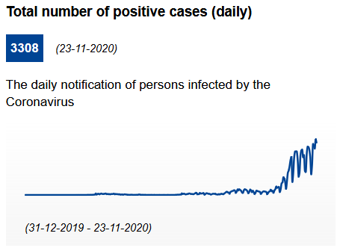 | Infection rate (cumulated past 14 days): 894.74 cases per 100.000 inhabitants.  General information: Facemasks generally mandatory in all closed public spaces. No curfew. Public gatherings are limited to 50 people. Weddings and funerals are limited to 30 people. Private gatherings are limited to 15 people. Organisers of public events with more than 15 people have to collect the personal contact information of all attendees. Shops are open, but the general public health recommendations on physical distancing, personal hygiene and disinfection should be maintained. On July 2020 the government launched the STOP COVID-19 app.  Hotels: Following the general public health recommendations on physical distancing, personal hygiene and disinfection, these services are open. For more details you can read the recommendations for hotels and renters  Bars and restaurants: Restaurants, bars and cafés can operate from 06.00 to midnight. Guests have to wear face masks, except while sitting in their seats and having dinner. Employees in the catering industry, who come into contact with guests or participate in the serving and preparation of food and beverages, have to wear face masks also.
Cyprus  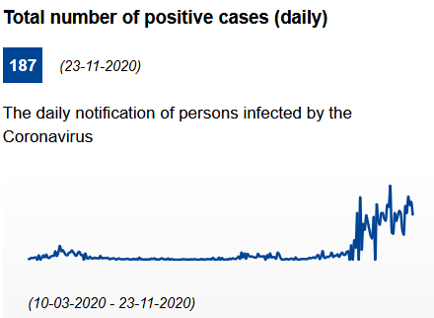 | Infection rate (cumulated past 14 days): 303.23 cases per 100.000 inhabitants.  General information: Emergency measures valid on an island-wide basis are in force for the period 04.11.2020 – 30.11.2020. According to these measures, the movement of citizens is banned from 23:00 to 5:00, apart for movement for essential reasons, provided that the relevant certificate or documentary evidence is available. Stricter measures in place in Lemesos and Pafos (curfew from 20:00 to 05:00; essential movements only, gatherings prohibited). Facemasks mandatory in all public spaces. Physical distancing measures of 2 metres outdoors and 3 metres indoors are in place. Gatherings in houses and public places are allowed with a maximum number of 10 people. Events such as conferences, trade and visual exhibitions assemblies and/or events in indoor conference venues are not allowed. Shops are open, but the operation of indoors shopping centres, malls and large stores with an area bigger than 500 square metres is suspended in Lemesos and Pafos.  On July 2020 the government launched the STOP COVID-19 app.  Hotels: Following the general public health recommendations on physical distancing, personal hygiene and disinfection, these services are open. For more details you can read the recommendations for hotels and renters  Bars and restaurants: Restaurants and catering establishments in general (i.e. estaurants, catering services in hotels and tourist accommodations, catering services in malls and department stores, taverns, cafeterias, pizzerias, pubs, snack-bars and bars, coffee shops, canteens and/or refectories of sports clubs, cultural clubs, associations, societies, etc.) are allowed to operate until 22:30 apart for home delivery, that may be in function also after 22:30. Catering services at the Airports of Larnaka and Pafos are excluded from the prohibition. The maximum number of customers allowed to be served is set at 75 people in indoor areas and 150 people in outdoor areas. The maximum number of customers who can sit at the same table may not exceed 6 people. In Lemesos and Pafos, The operation of restaurants and catering establishments in general is suspended, with the exception of home delivery and takeaway that may function in the allowed time slot (from 05:00 to 20:00).
Czech Republic  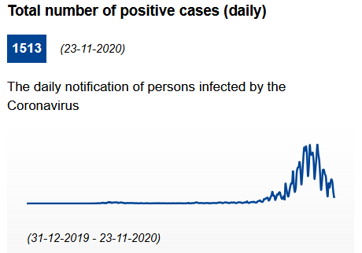 | Infection rate (cumulated past 14 days): 721.1 cases per 100.000 inhabitants.  General information: As of 22.10.2020, a new lockdown measure as well as a night curfew between 23:00 and 5:00 are in place and only exceptional movements for essential reasons are allowed (health and work-related movements). Furthermore, non-essential services and shops must remain closed. Essential shops can be open until 20:00 and must be closed on Sundays. The state of emergency has been extended until 12.12.2020. As of 18.09.2020, the usage of a mask is mandatory in public places. Physical distance should be kept whenever possible, with some exceptions. In all establishments a 2-metres distance has to be maintained. As of 23.11.2020, only six people will be able to move about together in public places and the right of assembly outdoors, with a maximum of 100 people in groups of twenty is allowed.  General safety measures for establishments: https://koronavirus.mzcr.cz/wp-content/uploads/2020/05/specifikace_pokyny_2505.pdf. Recommended tracing app: eRouška. A system called "smart quarantine" is in place.  Hotels are closed, but they can be available for specific purposes, such as people travelling for business reasons, in case of foreigners before they leave the territory, or foreigners who have a business permit in the Czech Republic, as well as for providing a location for people in need of isolation and quarantine. Restaurants can be open for guests between 5:00 and 22:59.  Bars and restaurants are closed but delivery and takeaway options are still in function. The takeway mode works until 20:00, while food delivery can work all day long, with social distancing and hygiene measures in place. Drinking alcohol is prohibited in the premises of restaurants and in public places in general.
Denmark  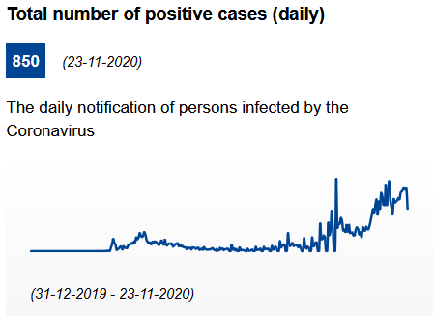 | Infection rate (cumulated past 14 days): 264.62 cases per 100.000 inhabitants.  General information: On 23 October 2020 the Danish Government decided to introduce a series of new restrictions effective from 26 October 2020 until 2 January 2021. The new restrictions include the requirement to wear face masks in retail shops and to some extent at educational institutions as from 29 October 2020. Social distancing of at least 1-metre distance in general. At least 2-metres distance in certain situations such as contacts with risk groups. A temporary ban on holding or attending events, activities or similar where more than 10 people are gathered is in place until 13.12.2020. The ban does not apply in private homes, where 500 people are allowed to gather simultaneously. However, citizens are advised to gather in private homes only with close friends and family members, observing social distancing and hygiene measures.  Shops are open. In shops and supermarkets, a limited capacity of four square metres per each customer has to bee guaranteed, reduced at two square metres if seats are available. Restrictions were introduced on the sale of alcohol in supermarkets and kiosks after 22.00 and everybody was encouraged to limit the number of social contacts. In addition, border control was intensified. Maximum number of 10 people at gatherings except from funerals at which 50 people are allowed. These restrictions will be effective until the end of 13 December 2020. As of 09.11.2020 and at least until 03.12.2020, additional restrictions, including a curfew, are in place in the municipalities of Hjørring, Frederikshavn, Brønderslev, Jammerbugt, Vesthimmerland, Thisted and Læsø.  Recommended contact tracing app: smittestop.dk  Hotels are allowed to remain open. Horesta has developed a ’Safe to Visit’ label.  Bars and restaurants: Restaurants, bars and cafés can be open between 5:00 and 22:00 and all guests must wear a face mask except when seated. Groups of more than 10 people are not allowed and the distance between tables has to be of 1 metre at least. The sale of alcohol is prohibited from 22:00 and a voluntary registration of guests for the purpose of infection detection could be in place. Information posters stating the maximum number of people allowed must be displayed at the entrance.In North Jutland temporary local restrictions apply and restaurants, bars and cafés must be closed with the only exception of takeway. Discos, nightclubs and similar establishments must remain closed.
Estonia  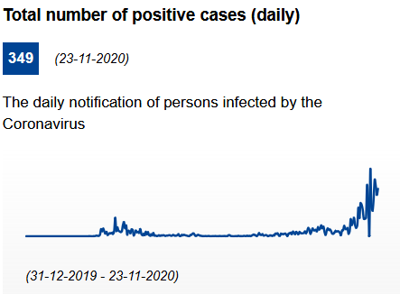 | Infection rate (cumulated past 14 days): 271.66 cases per 100.000 inhabitants.  General information: Wearing a mask or a similar means that cover nose and mouth is mandatory indoors. Shops are open. No curfew. As of 16.11.2020, the 2+2 rule is in place in service halls and public areas of commercial enterprises, meaning that no more than two people may move together and at a distance of at least two metres. A 10 + 2 rule applies in catering, entertainment and cultural institutions . The 10 + 2 rule means that a maximum of ten people can be together and a distance of 2 metres must be kept from other people. Public events, such as performances, concerts, festivals, folk cultural events, fairs, conferences, etc. are allowed with a maximum number of 500 visitors outdoors or 400 visitors indoors with stationary seats. Entertainment establishments must close their doors to guests from midnight to 6:00. A nationwide restriction on the sale of alcohol is in place. Accordng to this, late-night alcohol sales is forbidden from midnight to 10:00 in all points of sale where alcohol is sold for consumption on the spot, for example, bars, nightclubs, restaurants, theatre buffets and hotels.Stricter measures apply in Harju County and Ida-Viru County.  Information published by the Health Board are available at: Health protocols for tourism. Recommended contact tracing app: HOIA  Hotels: Tourist accommodations are open to visitors, with precaution methods and processes in order to ensure people safety.  Bars and restaurants: As of 16.11.2020 restaurants, bars, cafés and all catering establishments in general are closed from midnight to 6:00, with the exception of takeway. A 2-metres distance from other people must be observed and disinfectants must be made available for clients, in order to apply hygiene measures.
Finland  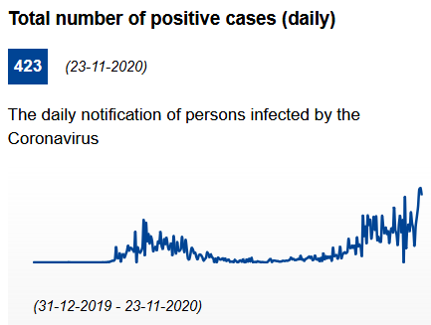 | Infection rate (cumulated past 14 days): 69.63 cases per 100.000 inhabitants.  General information: The use of masks in public transportation and among the public in areas that experienced covid-19 cases within the last 14 days is recommended. Maintaining physical distance of 1-2 metres is recommended. Non-essential shops are open with the following safety measures: limitation of the number of visitors, physical distancing and guidance on personal hygiene. The restrictions and recommendations concerning events, gatherings and meetings differ from one region to another depending on the phase of the epidemic (stable phase, acceleration phase, or community transmission). The guidelines on good hygiene and safe distances are in force at all phases.  Health protocols for domestic tourism are available: Guidelines. Recommended contact tracing app: Koronavilkku.  Hotels are open but many are forced to keep their services closed due to lack of customers as well as financial reasons.  Bars and restaurants: In restaurants throughout Finland customers must have their own seat. In the provinces that currently see the largest increases in contagions, namely Uusimaa, Southwest Finland, Pirkanmaa, Kanta-Häme, and Ostrobothnia, establishments must stop serving alcoholic beverages by 22.00. All food and beverage service establishments may be open until midnight at the latest. Restaurants may allow three quarters of the normal number of customers in the premises at a time. In the other regions, establishments must stop serving alcoholic beverages by midnight, and food and beverage service establishments may be open round the clock. There are no restrictions on the number of customers. Establishments that primarily serve alcoholic beverages must close by 01.00.
France  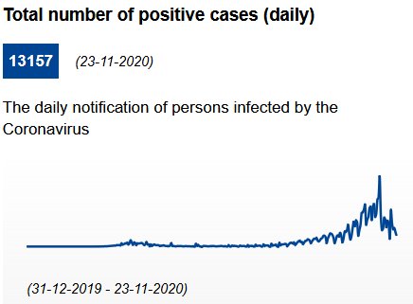 | Infection rate (cumulated past 14 days): 526.59 cases per 100.000 inhabitants.  General information: France has entered a new national lockdown since 30 October. The rules will be in place at least until 1 December. Only essential movement is allowed and a certificate is required. People will be allowed to leave their home only to go to work (if they cannot work from home), to buy essential goods, seek medical help or to exercise for one hour a day. The lockdown has replaced the previous curfew measures in place during October; except in the Paris area (22:00). Masks are compulsory in enclosed public places. A physical distancing of at least 1 metre applies in all places and circumstances. Mass gatherings with more than 6 people are prohibited. Exceptions apply in case of professional meetings, transport services, funerals (within the limit of 30 people). All non-essential shops must shut until at least 1 December, but schools and creches will remain open. Social gatherings are banned.  Health protocols for tourism services and tourists. TousAntiCovid is available since 2/6/2020. The App allows the user to be notified of possible close contact (less than 1 metre for at least 15 minutes) with someone who has then been tested positive to Covid.  "TousAntiCovid" is available at bonjour.tousanticovid.gouv.fr  Hotels must remain closed.  Bars and restaurants must remain closed until at least 1 December and an extension of this deadline is expected, possibly to 15 January 2021. Take-away and delivery services remain authorised (curfew of 22:00 in Paris)
Georgia  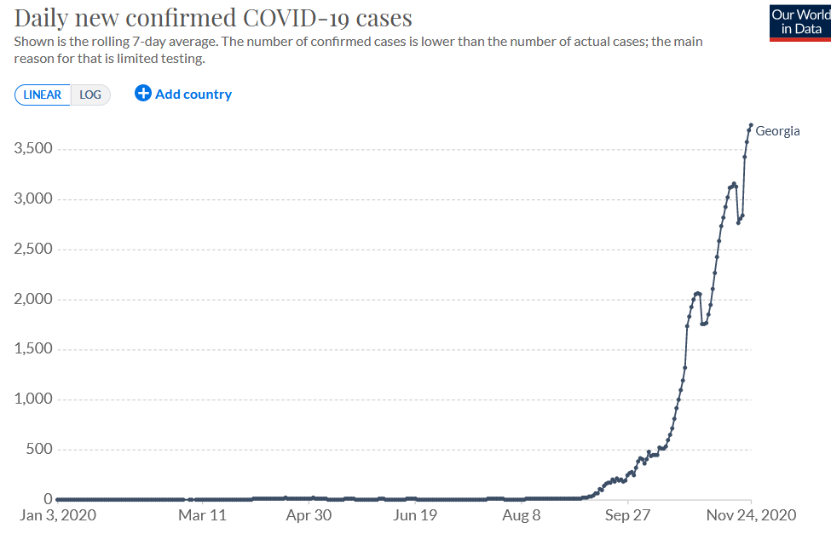 | General information: Effective November 9, the Government of Georgia imposed movement restrictions in major cities between the hours of 10pm and 5am in an effort to curtail the COVID-19 pandemic. During the restricted time, public and private transportation, including walking, is not permitted, unless it is for an essential need (for example, medical services). Social events such as weddings and funerals are limited to 10 guests. Although most types of outdoor activities are now allowed, sports and cultural events are limited to 200 people.  Hotels, bars and restaurants: Restaurants and hotels are subject to periodic ongoing health inspections. Customers in restaurants are required to wear masks when moving about indoors, and to maintain social distancing measures, with a maximum of six people allowed at one table. Restaurants are required to close at 10 pm nationwide.
Germany  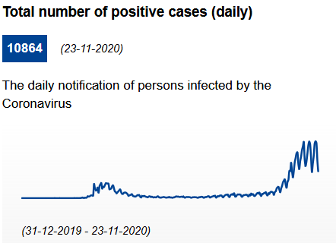 | Infection rate (cumulated past 14 days): 309.89 cases per 100.000 inhabitants.  General information: From 2 November, new restrictions across the country will include closures of cinemas, theatres, gyms, pools and saunas, as well as restaurants and bars, except for takeaway. Irrespective of the amount of sales space, shops observing enhanced hygiene requirements may open for business again. Personal contacts between households must be restricted to an “absolute minimum”. Meetings in public places are limited to two households with maximum 10 people. Large-scale events are prohibited. All non-essential travel strongly discouraged. However, schools and creches will stay open and visits to nursing homes will be allowed. Shops and hairdressers will be able to stay open, with strict hygiene rules and limits on the number of customers. Church services and protests will also be permitted. The measures will stay in place until 30 November.  Each federal state can set specific rules for the maximum number of people that are allowed to meet at a same location, with different limits applicable to indoor and outdoor spaces. Länder are also responsible for setting rules on wearing facemasks and can enact local curfew measures. An increased cleaning and ventilation of rooms, as well as the collection of personal data of guests, are mandatory in most Länder. In addition to the existing interpersonal distancing rules, there are Länder-specific restrictions on access, opening, residence and hygiene.Details on the current restrictions in the various Länder are available on the tourism guide webpage.  Recommended contact tracing app: Corona-Warn-App  Hotels: From 2 to 30 November, hotel stays for touristic purposes are prohibited.  Bars and restaurants: From 2 to 30 November restaurants, bars and cafés will be closed (except for take-away).
Greece  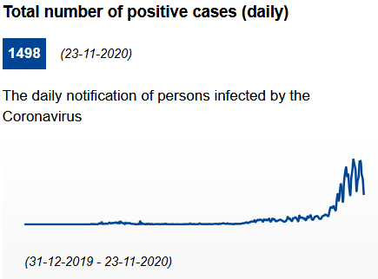 | Infection rate (cumulated past 14 days): 352.62 cases per 100.000 inhabitants.  General information: As of 7.11.2020 and for three weeks, a general nationwide lockdown is imposed. Citizens in need of going out for essential reasons will have to notify it and to provide specific certificates according to the reasons of their movement. Furthermore, as of 13.11.2020, from 21:00 to 05:00 only essential movement is allowed (work, health, pet care). The use of facemasks is mandatory both indoors and outdoors. Gatherings with 4 or more people are not allowed. Individual sport with a maximum number of three people is allowed. Special social distancing rules have been set for a wide range of places. Retail shops are temporarily closed, except for supermarkets, pharmacies, food delivery stores and hospitals.  Safety protocols for tourism services.  Hotels: Tourism accommodations are available under specific hygiene protocols.  Bars and restaurants are temporarily closed. However, home delivery and takeaway services are available also between 21:00 and 05:00, within the permitted movements during these hours.
Hungary  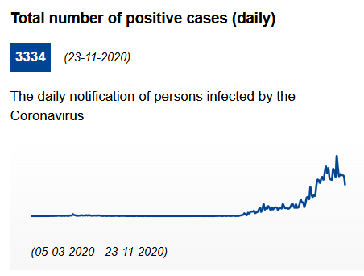 | Infection rate (cumulated past 14 days): 646.43 cases per 100.000 inhabitants.  General information: As of 05.11.2020, a curfew is in place from midnight to 5:00 and only essential movements are allowed. Shops may be open between 5:00 and 19:00. As of 11.11.2020, mask wearing is mandatory also in some public areas of municipalities with more than 10,000 inhabitants. Gathering in groups are forbidden and a general ban on events is in place. Family meetings are allowed with a maximum number of 10 participants. Music and dance events for over 500 people are still not possible.  Guidelines available for tourism services: The Covid manual of the Hungarian Tourism Agency and Reccommendations for reopening restaurant terraces and gardens. Recommended contact tracing app: VirusRadar  Hotels: Tourism accommodations are open only for guests arriving for business, economic or educational purposes. Safety and hygiene measures are in place, wearing a face mask is mandatory as well as maintaining a safety distance of 1.5 metres at least.  Restaurants and bars are temporarily closed and only home delivery is in place. As of 03.11.2020, nightclubs must be closed.
Iceland  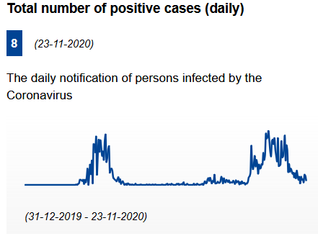 | Infection rate (cumulated past 14 days): 55.74 cases per 100.000 inhabitants.  General information: facemasks must be worn wherever a social distance of 2 metres cannot be respected. The maximum number of people allowed to gather is 10, whether in public or private spaces. However, this number restriction does not apply to household members in their homes. Shops are open; a maximum number of 10 customers can gather inside stores, as long as it is possible to ensure a 2-metres distance between people. As far as essential shops are concerned (i.e. pharmacies and grocery stores), the maximum number of people allowed is between 50 and 100.  Health protocols for tourism. Recommended tracing app : Rakning C-19  Hotels: only a limited number of hotels have remained open.  Bars and restaurants: Restaurants have to close at 21:00 and must comply with the current limit on the number of customers and proximity rules, i.e. a maximum number of 10 customers and a minimum distance of 2 metres. Pubs, bars and cafés are closed. Home delivery is allowed also after 21:00. It is required to wear a mask whenever possible.
Ireland  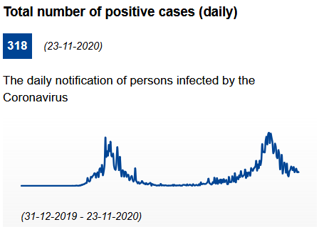 | Infection rate (cumulated past 14 days): 103.32 cases per 100.000 inhabitants.  General information: The government has decided that, as of 21.10.2020, all of Ireland is placed on Level 5 of the Plan for Living with COVID with a small number of exceptions. Level 5 restrictions – the strictest tier in Ireland’s response policy - will remain in place for a period of 6 weeks. Facemasks must be worn in indoor public spaces. Only essential retail shops and services remain open. People must remain within a 5-mile radius of their home; no gatherings or family visits authorised.  Hotels may remain open, but only to support provision of essential services.  Bars and restaurants (incl. wet pubs) may provide take-away and delivery services only. Wet pubs in Dublin remain fully closed.
Italy  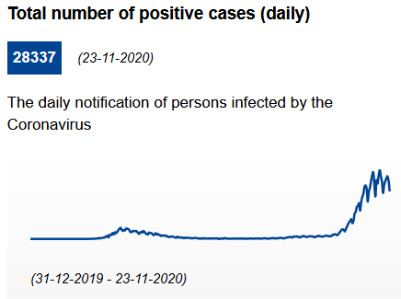 | Infection rate (cumulated past 14 days): 784.9 cases per 100.000 inhabitants.  General measures: From 5th of November to 3rd of December, the entire territory is split into 3 types of areas: yellow (default), orange (high-severity) and red areas (maximal gravity). Curfew in place nationwide from 22:00 to 05:00: it is prohibited to move without motivation proved by work needs, situation of need, or health reasons. For the remaining hours, it is strongly recommended not to travel, by public and private means of transport, except for work, study needs, for health reasons, for situations of need or to carry out activities or take advantage of non-suspended services. It is possible to close to the public, after 9 pm, streets or squares where the creation of gatherings is more probable, without prejudice to the transition to private commercial activities and homes. Movement between municipalities in orange and reed areas is heavily restricted. Gatherings are not allowed in public spaces and it is strongly recommended not to have guests in private homes. The consumption of food and drink in public places and places open to the public is prohibited from 18:00 to 05:00.  All shops may remain open in the yellow area (except on Sundays and Bank Holidays). In orange or red areas, non-essential shops are closed.  It is mandatory to wear masks in closed spaces. The specific interpersonal safety distance rule is: at least 2 metres in case of group sport activity and at least 1 metre in all the other circumstances..  Recommended contact tracing app: https://www.immuni.italia.it/  Hotels: As of 06.11.2020, restrictive measures vary according to the epidemiological level of the Italian regions. In all the areas: the activities of accommodation facilities (hotels, non-hotel, short-stay and farm holiday hotel accommodation) are allowed, provided that the interpersonal safety distance of one metre is guaranteed in the common areas and strict hygiene measures are in place. Guidelines for accommodation  Restaurants and bars in yellow areas are open from 05:00 to 18:00, with a maximum of 4 guests allowed for each table (except for cohabiting people). They are closed in orange and red areas. Delivery services are allowed everywhere without any time limit. Takeaway services are allowed until 10 p.m. (the consumption of food and drinks is forbidden on site or nearby). A sign indicating the number of people admitted inside at the same time must be displayed at the entrance to each bar, pub and restaurant. Bars and restaurants at the airports, highways and hospitals are open without time limit. Activities that take place in ballrooms, nightclubs and similar venues, outdoors or indoors, remain suspended.
Latvia  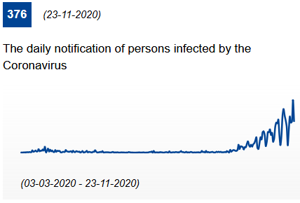 | Infection rate (cumulated past 14 days): 261.72 cases per 100.000 inhabitants.  General information: Latvia’s government declared a four-week reinforcement of restrictions starting on 09.11.2020 until 06.12.2020. The use of masks is mandatory in indoor public settings, and outdoor areas that are adjacent and part of a given facility. If a large number of persons is present at a site where the two-metre physical distance cannot be ensured and the spend time together is likely to exceed 15 minutes, a physical barrier between persons shall be created, or the use of mouth and nose covers is required. People must respect 2 metres physical distancing. For private events, not more than ten people from two households are allowed to get together, with the exception of funerals. With some exemptions (such as demonstrations and rallies) large public events are banned. Non-essential shops can open during working days only. In weekends, only essential stores, such as grocery stores, pharmacies, veterinarian pharmacies, pet stores, bookstores, newsstands, optical stores, hygiene goods and household stores, telecommunication stores will be opened in shopping centers.  Recommendations for tourism available here: Latvia travel recommendations. Recommended contact tracing app: Apturi  Hotels can stay open on the condition that physical distancing and epidemiological safety measures are being followed. By complying with recommendations, including disinfection of surfaces and others, and ensuring that social distancing requirements are followed, hotels and guest houses can operate and admit guests.  Restaurants and bars can only provide take away services.
Liechtenstein  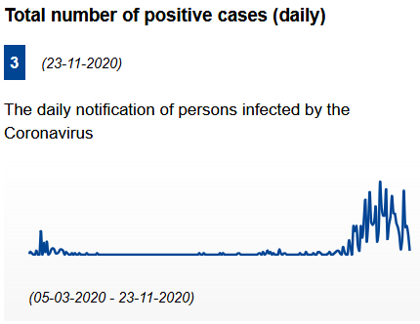 | Infection rate (cumulated past 14 days): 844.23 cases per 100.000 inhabitants.  General information: On 10.11.2020 in light of rising levels of COVID-19 infections, the Liechtenstein Government announced that it will be extending measures taken to mitigate the spread of the virus through 29311.2020. This includes measures implemented on October 21 and 24, respectively that the wearing of masks are required inside all public buildings. Eating and drinking at public events is also prohibited. Since November 4, private events that have not developed protective procedures are only allowed for up to 10 people. Larger private events must fulfill the same requirements as large public events, including a minimum social distancing of 1.5 meters and the wearing of masks when indoors. The consumption of food or beverages at large private events is prohibited.  Bras and restaurants are closed, as well as nightclubs.
Lithuania  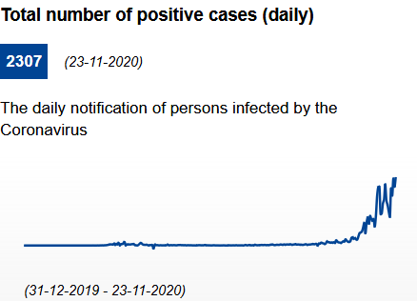 | Infection rate (cumulated past 14 days): 799.8 cases per 100.000 inhabitants.  General information: It is recommended to restrict movement for non-essential reasons; leave the place of residence only for the purpose of work, shopping, health and other services. Face mask are mandatory on public transport and in enclosed shopping and service provision locations. A distance of 2 metres between people must be ensured (except for members of the same family). The safety distance may be less if there is a partition or if personal protective equipment is worn. Distances in queues are at least 1 metre. Further local restrictions can be applied. No indoor or outdoor commercial or non-commercial cultural, entertainment, sporting events, celebrations, fairs, festivals or other mass gatherings arranged in public locations. It is recommended to restrict close contact with members of other families and/or households or meet with members of no more than 2 families and/or households wearing masks.  Recommended contact tracing app: Korona Stop LT  Hotels: The accommodation sector is required to accommodate a maximum of 2 people in one room, except for family members; to ensure that everyone wears a face mask and maintains a distance of at least 2 meters between people or groups of people (up to 5 people or family members) in common areas.  Bars and restaurants are closed, except for take away or delivery. Catering can still be provided in certain circumstances such as for staff of enterprises, or in educational institutions, social care, and health care.
Luxembourg  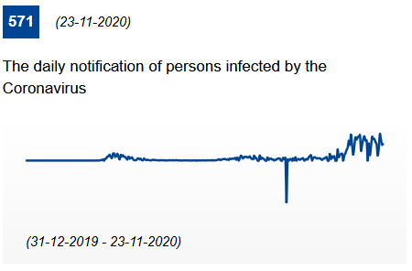 | Infection rate (cumulated past 14 days): 1279.05 cases per 100.000 inhabitants.  General information : Between 23:00 and 6:00 a curfew is in place and only essential movement is allowed. Facemasks (any protection covering nose and mouth) are mandatory when the social distance of 2 metres cannot be respected. Both indoor and outdoor gatherings are permitted, provided that the protective measures are in place. During public gatherings of more than 10 people, seats must be assigned and a safety distance of 2 metres has to be maintained. As far as private gatherings are concerned, a maximum number of 4 people is required (the +4 rule), whether indoors (at home) or outdoors (in a park). All shops are open; any commercial operation with a sales area equal to or bigger than 400 square metres, which is accessible to the public, is subject to a limitation of one customer per 10 square metres.  Health protocols for tourism services and tourists (in English).  Hotels: no specific rules apply  Bars and restaurants: he following measures apply: a distance of 1.5 metres between the tables is mandatory. If this cannot be done, customers must be separated by plexiglass screens; no more than 4 people may sit at the same table (except for cohabitants); customers must wear a mask while they are not seated; staff members who are in contact with customers must wear a mask; closing time is at 23:00 at the latest; the consumption at the table is compulsory (except for takeaway or delivery); a total number of 100 clients can be present in the establishment.
Malta  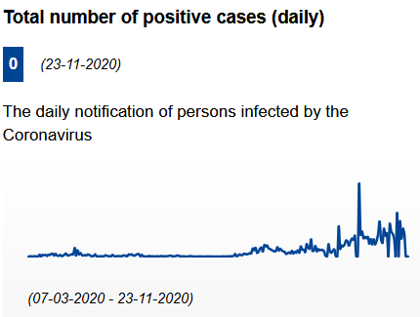 | Infection rate (cumulated past 14 days): 308.17 cases per 100.000 inhabitants.  General information: The use of face masks is obligatory in all indoor and outdoor public places. Physical distancing of 2 metres. In public places, groups of more than 6 people are prohibited. All shops are open.  Guidance about bars, clubs and similar establishments, museums and other cultural places, open air theatres, personal services, indoor pools and entertainment areas, travel on public transport and other is available at covid19health.gov.mt, at visitmalta.com and at mta.com.mt. Recommended contact tracings app: COVIDAlert.  Hotels are open - Standards for hotels and similar establishments  Bars and restaurants: Restaurants are open, provided that a limited capacity of one person per 6 square metres indoors and one person per 4 square metres outdoors is in place. A maximum number of 10 people can sit at the same table and a distance of at least 2 metres is required between tables. Masks are mandatory in common areas. Standards for restaurants and similar establishments
Netherlands  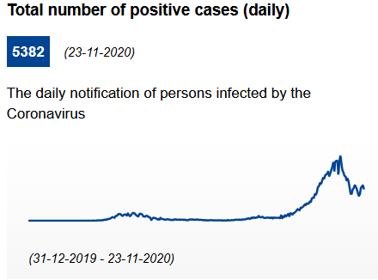 | Infection rate (cumulated past 14 days): 431.01 cases per 100.000 inhabitants.  General information: People are advised to stay at home as much as possible. Locally, it is advised to limit the number of outings and avoid busy places. The general advice is to work from home, unless this is really not possible. In general, it is strongly advised to wear a face mask in all indoor public spaces. Retails shops must close no later than 20.00. Grocery stores may stay open later. Additional measures can apply to the safety regions that are currently seeing the sharpest increase in coronavirus infections, and marked 'serious'. You can host no more than 3 guests in your home, garden or balcony per dayOutdoors, no more than 4 people from different households can form a group. Consumption of alcohol in public spaces is prohibited between 8:00pm and 7:00am.  Health protocols for tourism services and tourists. Recommended contact tracing app: CoronaMelder app  Hotels: Tourist accommodations are open. Campsites and holiday parks are open. Locations with a combined function must close the section that serves food and drinks.  Bars and restaurants: Restaurants, cafés and outdoor seating areas are closed. Take-away will still be possible. Discotheques, night clubs and similar dance venues are also closed. Locations with a combined function must close the section that serves food and drinks.
Norway  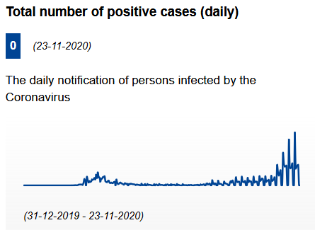 | Infection rate (cumulated past 14 days): 154.14 cases per 100.000 inhabitants.  General information: On 05.11.2020, the Government recommended to everyone to stay at home and limit social contact with other people as much as possible. The use of masks is not required in public but recommended in public transport. Social distancing of minimum 1 metre. All shops are open. Private gatherings of less than 5 people authorised; up to 200 people can be gathered at an indoors public venue, provided that an event organiser can be held accountable for it. Up to 600 participants can be gathered at an outdoors public venue, provided that the participants are kept in separate groups of up to 200 people.  In areas characterized by a higher epidemiological risk, further restrictions may apply and the use of face masks is mandatory on public transport to/from and within the region as well as inside public places such as shops and malls where it is not possible to keep a distance of one metre from other people. The use of face masks becomes mandatory ualso in establishments serving food or alcohol such as restaurants, cafes, bars, pubs, nightclubs etc. This applies to both employees and guests in all situations except when seated at a table. hosting more than 20 participants at an indoor event without fixed seats is prohibited. The number of people you are in contact with in a social context should not exceed 10 during a week, excluding members of the same household.  Hotels can remain open.  Bars and restaurants: In restaurants, bars and cafés a distance of at least one metre between seated people has to be kept, apart for members of the same household. A requirement on contact details registration is in place. Requirements for serving food and alcohol  In areas characterized by a higher epidemiological risk, further restrictions may apply, such as no serving of alcohol after midnight or closure time at 22:00 in order to reduce the number of visitors during the evening.
Poland  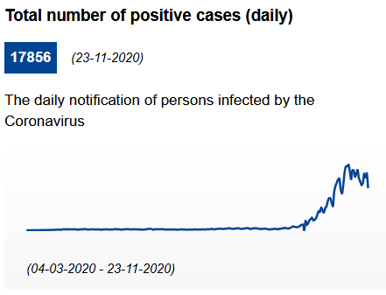 | Infection rate (cumulated past 14 days): 829.29 cases per 100.000 inhabitants.  General information: Poland uses a three tiered alert system: as of 24.10.2020; the whole country is considered as a red zone and stricter measures are in place: maximum number of 5 customers is allowed in shopping stores with a surface of up to 100 m²; gatherings of more than 5 people are banned; and cultural events will be held with only 25% of available seats occupied. Wearing masks is compulsory in public places across the whole Poland. Shops in shopping malls are closed. The operation of shopping malls and retails centres is limited.  Health protocols for tourism services and tourists (in Polish) Recommended contact tracing app: ProteGO Safe.  Hotels can remain open, following strict rules and in the following cases: for guests travelling on business; for people participating in training camps and sports competitions;for medical professionals – in relation to the so-called “Hotels for medics” programme; for patients and their carers (e.g. cancer patients and patients undergoing dialyses, little patients under the care of adults). Workers hostels are also allowed to operate. Swimming pools and fitness centers gyms are available only to hotel guests staying at least one day. Catering establishments are available under a strict sanitary regime which implies the necessity of using face masks and of respecting a 1.5 metres distance between tables, unless there is a one meter high partition between them.  Bars and restaurants: As of 24.10.2020, the entire territory of Poland is classified as a red zone and only takeway and delivery options are in function.
Portugal  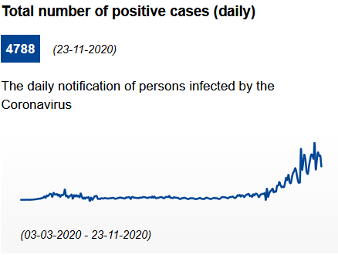 | Infection rate (cumulated past 14 days): 732.42 cases per 100.000 inhabitants.  General information: On the entire continental territory, there is a prohibition of movement between municipalities between 23.00 and 05.00 between 27.11.2020 and 02.12.2020. Four levels of severity of the pandemic are distinguished at municipal level: moderate, high, very high, and extremely high. In high-risk areas, citizens should remain at home as much as possible; a curfew is in place between 23.00 and 05.00 on weekdays and from 13.00 to 05.00 during the weekends. In between these times, people may only leave the house for strictly essential needs, professional purposes (declaration is needed), or to seek/provide help (see the official list of exemptions). Trips must be made individually whenever possible, and must respect the recommendations and orders determined by the health authorities and the security forces and services.  The use of face masks is mandatory for residents aged 10 years or over in all public indoor spaces. It is also mandatory in all other outdoor spaces and workplaces where it is not possible to maintain 2 metres distance and when people are not from the same household. Events and celebrations are limited to 5 people, unless from the same household. For a selection of municipalities stronger measures are enforced all gatherings are limited to 5 people.  In moderate risk municipalities: all retail and service establishments must close between 20.00 - 23.00 upon decision by the mayor. In high-risk municipalities: commercial establishments should close at 22.00. In very-high-risk and extremely high-risk municipalities: commercial establishments should close at 22.00 and observe stricter opening hours during weekends.  Recommended contact tracing app: StayAway COVID  Hotels: may open with the adoption of the "Clean & Safe" seal which identifies of establishments and services that have implemented enhanced hygiene and safety measures.  Bars and restaurants: In the areas not considered high-risk, restaurants can be accessed until midnight, and should close at 01.00. The capacity is limited to 50% of normal capacity. Groups are limited to 5 people, unless they belong to the same household. A maximum of 4 people can be in establishments within 300 metres of a school and in the food courts of shopping centres. It is mandatory to book in advance. In high-risk municipalities: catering establishments should close at 22.30. In very-high-risk and extremely high-risk municipalities: commercial establishments and services, are only allowed to open between 8:00 and 13:00.
Romania  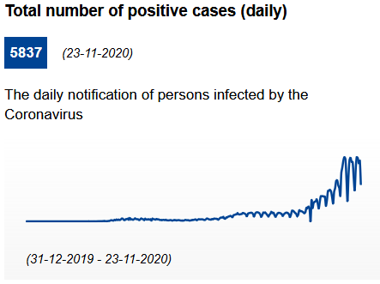 | Infection rate (cumulated past 14 days): 591.8 cases per 100.000 inhabitants.  General information: As of 09.11.2020, due to the worsening of the epidemiological conditions, additional restrictions are in place as well as a night curfew. The use of face masks is mandatory in all closed public spaces. Maximum 16 people are allowed for private events in closed spaces. All open space gatherings and all other indoor activities are still forbidden.As of 09.11.2020, a ban on events is in place. Shops providing outside delivery are open (except malls, unless mall-based outlets have street entrances only). Stores with direct street access will need 4 square metres per customer and periodic disinfection of cashier and other significant areas. As of 09.11.2020, shops have to close at 21:00 and fairs and markets are banned.  Recommended contact tracing app: CovTrack  Hotels: Hotels will reopen maintaining social distancing (1.5 metres between customers, 4 square metres per customer and periodic disinfection of cashier and other areas). Wearing a mask is mandatory. Indoor restaurants and bars, playgrounds and indoor fitness, sauna and pool facilities in hotels remain closed. Food is served through room service regime.  Bars and restaurants: It is allowed to sell food and beverages (alcoholic and non-alcoholic) in "drive-in" mode, "room-service" and delivery to the customer (take away). Health protection measures are in place, such as a minimum distance of 2 metres between tables and a maximum number of 4 people at each table, if they do not belong to the same household. In certain high-risk areas, stricter rules may apply and restaurants, bars and cafés can be closed.
Serbia  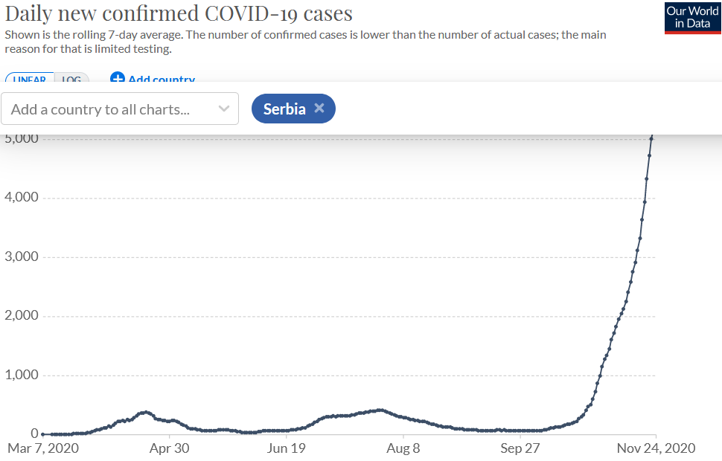 | General information: Effective 17.11.2020 until at least 1.12.2020, all services, including bars, restaurants, cafés, stores, supermarkets, shopping malls, theaters, and cinemas will be closed from 21:00 and 05:00. These restrictions do not apply to pharmacies, gas stations, and food delivery services. Ban on public gatherings involving more than 5 people, indoors or outdoors. No more than one person per 4 square meters is allowed indoors. The use of face coverings is required in all indoor locations, as well as outdoors when required physical distancing is not possible. Face coverings are recommended elsewhere outdoors. No curfew or movement restrictions in place.  Hotels are open.  Bars and restaurants: must close between 21:00 and 05:00
Slovakia  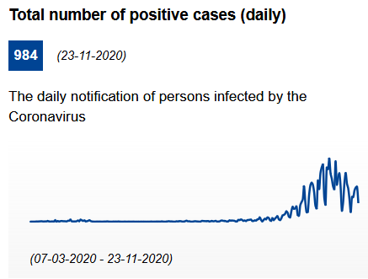 | Infection rate (cumulated past 14 days): 380.63 cases per 100.000 inhabitants.  General information: As of 24.10.2020, a partial lockdown is in place. People visiting closed public spaces required to wear face masks or otherwise cover their faces with mask-like substitutes (scarves, shawls, etc.). Shops are open, but hygiene measures as well as a limited capacity of 15 square metres per each customer are in place. If the total area is smaller than 15 square metres, only one customer at a time is allowed to enter. Access to shopping malls is allowed only to people with a body temperature up to 37 ° C.  Guidelines available for tourism services: The Covid manual of the Hungarian Tourism Agency and Recommendations for reopening restaurant terraces and gardens. A contact tracing app is under development. Furthermore, the smart quarantine was approved by Parliament. Citizens will be able to use a free-of-charge mobile phone app instead of the state-organised quarantine.  Hotels: Tourism accommodations may be closed, according to the epidemiological situation.  Restaurants and bars: Indoor catering establishments are closed. As far as outdoor terraces is concerned but strict hygiene and distancing measures are in place. Catering establishments may be open between 5:00 and 22:00, with the exception of delivery services and sales using dispensing windows. Food and drinks may be served only in a packaged state.
Slovenia  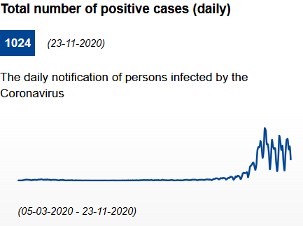 | Infection rate (cumulated past 14 days): 968.18 cases per 100.000 inhabitants.  General information: The movement and gathering of people have been temporarily restricted in Slovenia. Movement of people on the entire territory of the Republic of Slovenia is temporarily prohibited between 21:00 and 06:00 with some exceptions. Movement between municipalities is prohibited with certain exceptions for which adequate proof must be submitted. Persons crossing a municipal boundary must carry with them adequate proof of the exception justifying their travel and a signed and legible statement.  Masks must be worn in all closed and open public spaces. Gatherings of people outside a family/household are not allowed. Public transportation has been stopped and non-essential shops closed since 13.11.2020.  Recommended contact tracing app: #OstaniZdrav  Hotels: Tourist accommodations are open. Catering in these establishments is allowed only at tables (seated service) with a distance of at least 1.5 metres between persons, except for persons from the same household.  Bars and restaurants: Restaurants, bars and cafés are closed, but pick up/delivery is permitted. The ban does not apply to catering activities in accommodation where catering activities may be carried out between 06.00 and 22.30, but only to guests staying in accommodation establishments.
Spain  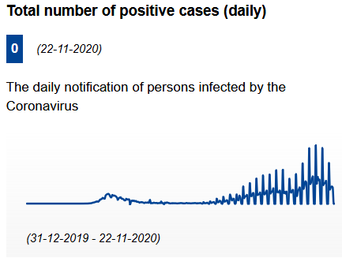 | Infection rate (cumulated past 14 days): 485.54 cases per 100.000 inhabitants.  General information: National curfew between 23.00 and 06.00 in place, Canary islands excluded. Autonomous regions have the authority to start the curfew an hour earlier, or later. Further regional and local restrictions can apply. There are several municipalities or regions that are subject to a perimetral lockdown, meaning residents cannot leave or enter the area unless it is for essential reasons, such as for work, to access care services or in the case of an emergency. Also, many municipalities without entry and exit restrictions have introduced other types of measures, such as a reduced capacity for restaurants, bars and cafes. Shops are open; special attention is required in commercial areas and street markets. Restrictions can differ between autonomous regions.  Face masks are mandatory in public spaces, indoors and outdoors. Most regions in Spain have made masks obligatory outdoors as well. Outdoor social gatherings are limited to 6 people. Physical distancing measures must be guaranteed and the maximum precautions must be taken to avoid meetings and overcrowding in indoor places.  The contact tracing app Radar Covid is currently being rolled out in regions across Spain after a pilot test in La Gomera.  Recommendations from the Spanish government for the service industry (in Spanish).  Hotels: Occupancy is often limited, and there can be restrictions on valet parking and ironing services. In-house restaurant services have to comply with the general disinfection and social distancing measures, as well as restricted opening hours.  Bars and restaurants are subject to national curfew measures. Staff must ensure that the measures on disinfection and social distancing are applied. Customers and employees have to maintain a safety distance of at least 1.5 metres in every condition and wear a face mask, removing it only when strictly necessary, for example to eat meals. It is forbidden to smoke in the open air when a safety distance of 2 metres cannot be maintained.
Sweden  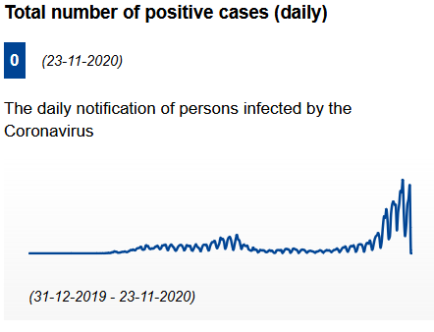 | Infection rate (cumulated past 14 days): 577.31 cases per 100.000 inhabitants.  General information: Sweden is the only EU country not to have enacted a general lockdown or curfew measures since the outbreak of the pandemic. There is no general requirement to wear a face mask in normal social situations, in public places, and in public transport. All public gatherings and events with more than 50 people have been banned. From 01.11.2020 the maximum number of people allowed at sport or public events is 300. Campsites are not included in the ban on public gatherings exceeding 50 people. Most shops and stores are open, but may have reduced opening hours and limits to the number of customers allowed.  Hotels: measures to reduce the risk of infection must be in place, such as arrangements to avoid queuing, a limit to the number of guests, social distancing, and hygiene measures. If there is a restaurant, bar, café or similar facility at the accommodation, it will be covered by the new rules for restaurants and bars.  Bars and restaurants: No crowding is allowed. Guests must respect physical distancing; food and drinks must be served at the table; guests must always eat their food while seated at a table; takeaway food can be purchased, as long as no crowding occurs. There is a limit of 8 people per table. Visita has launched a campaign that consists of three brochures including measures preventing infection in restaurants, hotels and campsites: Information for restaurants  From 01.11.2020 nightclubs and discotheques can allow a maximum of 50 people.
Switzerland  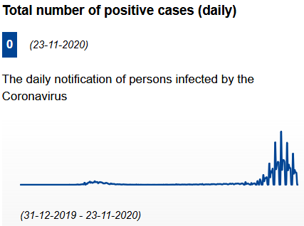 | Infection rate (cumulated past 14 days): 916.65 cases per 100.000 inhabitants.  General information: Face masks are compulsory in all publicly accessible indoor spaces such as shops, cafes, restaurants, museums, and publicly accessible areas of administrative buildings. Gatherings should be avoided were possible. At private events attended by more than 15 people, food and drinks may only be consumed while seated. Anyone standing up must wear a mask. Furthermore, hygiene rules must be observed at all times and contact details must be recorded. For private events of more than 100 people there must be a set of precautionary measures (as for public events) and may only be held in publicly accessible venues. Spontaneous gatherings of more than 15 persons are not permitted in public spaces such as town squares, streets, paths and parks. Shops are in general open, except in areas where stricter rules apply.  In the canton of Geneva, stronger measures apply: non-essential shops are closed and gatherings of more than five people in public spaces, particularly in public squares, busy walkways, parks and near bodies water are banned. Also banned are public and private events with more than five people, both inside and outside, including within the family circle. In Basel city, events are restricted to 15 people.  Recommended contact tracing app: swisscovid-app  Hotels: the "Clean & Safe" campaign establishes safety protocols for service providers.  Restaurants and bars: food and drinks may only be consumed while seated, both indoors and outdoors. Face masks are required. In the canton of Geneva, restaurants, cafés and bars are closed. In Basel city all restaurants, bars and cafés are closed, although takeaway and delivery is allowed (except between 23.00 and 05.00).
Turkey  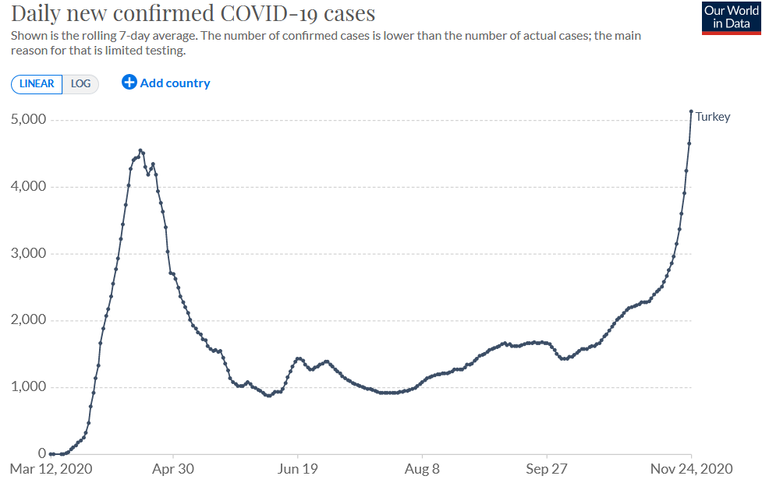 | General information: A new round of measures against the novel coronavirus took effect in Turkey on 20.11.2020, including a partial weekend curfew. A partial curfew that was already in place for people over the age of 65 was also expanded to include children and young people under 20, with the exception of those who have to go out for work. These will be allowed to leave their homes from 10 a.m. to 4 p.m. throughout the week. Movie theaters will remain closed until the end of the year. Malls, markets, restaurants and hairdressers will be open from 10 a.m. to 8 p.m. throughout the week. Education will continue online until the end of the year and all sports competitions will continue to be played without an audience. A smoking ban on crowded streets and other public areas are to continue.Public and private sector workplaces are to allow flexible working hours for their employees in a way that does not create tension.​​​​​​​  Hotels: Turkey’s ‘Safe Tourism Certification Program’ defines and advises an extensive series of measures to be taken with regards to transportation and accommodation of all Turkish citizens and international visitors who will spend their holidays in Turkey as well as the well-being and health conditions of passengers/guests and of employees working at touristic facilities Establishments that wish to apply for this verification program, which is compulsory fort the facilities with 50 and more rooms (30 and more by 01. 01.2021) and non-compulsory for facilities with less then 50 rooms (less than 30 by 01.01.2021) and for other defined areas will be able to do so by applying to authorized international accreditation institutions.  Bars and restaurants: May only provide delivery services.
United Kingdom  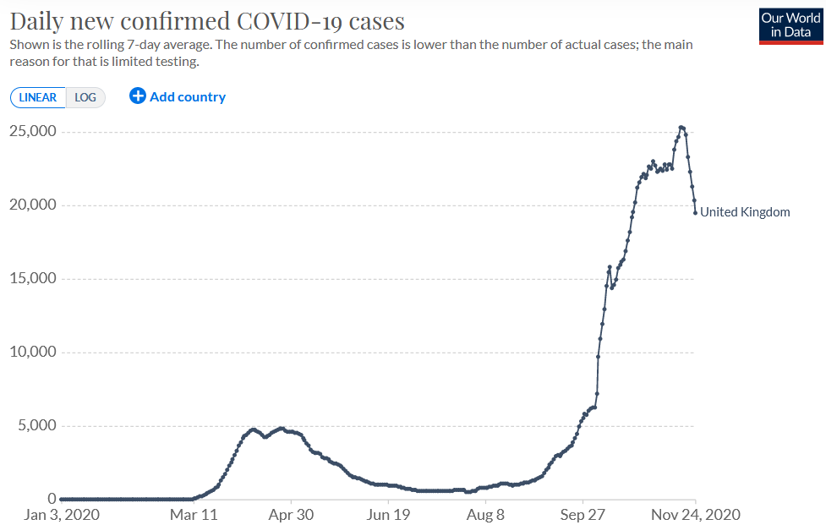 | Infection rate (cumulated past 14 days): 471.3 cases per 100.000 inhabitants.  General information: the four home nations (England, Scotland, Wales and N. Ireland) apply measures differently.  Every area of England is now in one of three categories - medium (tier one), high (tier two) or very high (tier three), depending on the local infection rate. CThe current lockdown will be in place until 2 December. People must stay at home; non-essential shops must close (click-and-collect/deliveries can continue), along with personal care services, including hairdressers. Supermarkets, food shops, off-licences, petrol stations and pharmacies can remain open, along with a few other shops such as garden centres and bike shops.  In Scotland, there is a five-tier system (from zero to four). There must be no non-essential travel between Scotland the rest of the UK.  Wales has eased lockdown restrictions since 9 November. Up to 15 people can meet for organised activities indoors, rising to 30 outdoors. All businesses required to close during the lockdown can reopen. Travel throughout Wales is permitted, but people can only go to England for essential purposes, such as work  N.Ireland will renew lockdown measures with stricter rules as of 27.11.2020.  Hotels: Strict hygiene and safety measures apply. Shared facilities should not be open. Hotels are closed in Wales and N.Ireland.  Bars, pubs, cafés and restaurants: in England, restaurants pubs and bars must close; only delivery services and takeaway authorized. After 2 December, bars and restaurants will be able to open until 23:00 in tier one areas; will need to serve food in tier two areas and will have to remain closed in tier 3 areas (with takeway and delivery authorized).  In the most heavily affected parts of Scotland (tier 4), all licensed premises - except hotel bars for residents - must close indoors and outdoors, though takeaways are permitted. Cafes can stay open until 6:00pm daily, but must not serve alcohol. In the rest of Scotland, pubs and restaurants can only open inside between 6:00am and 6:00pm daily, and cannot serve alcohol (they can only serve food and non-alcoholic drinks, but can serve alcohol outdoors until 10:00pm). Hotel restaurants can serve food after 6:00pm, but only for residents and without alcohol.  In Wales, hotels, bars and restaurants have reopened. In N.Ireland: closure of the hospitality sector, apart from deliveries and takeaways until 11:00pm; unlicensed premises such as cafés can open until 20:00, but will need to fully close for two weeks as of 27.11.2020. .

